Thursday

Breakfast

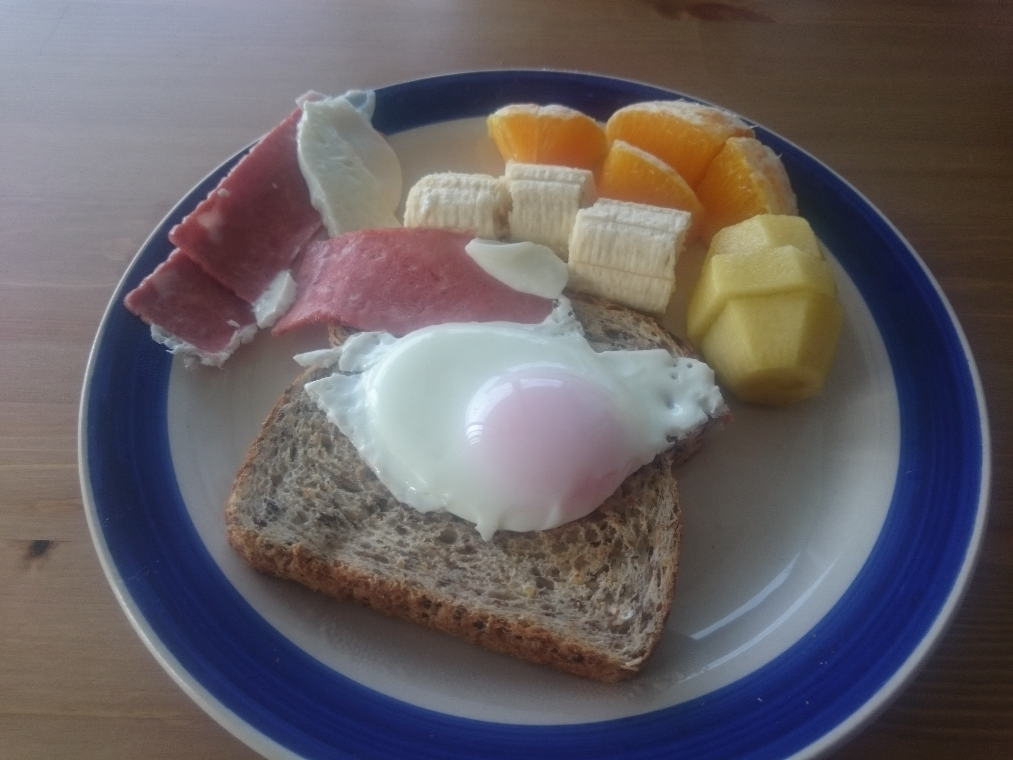

Lunch

and rice

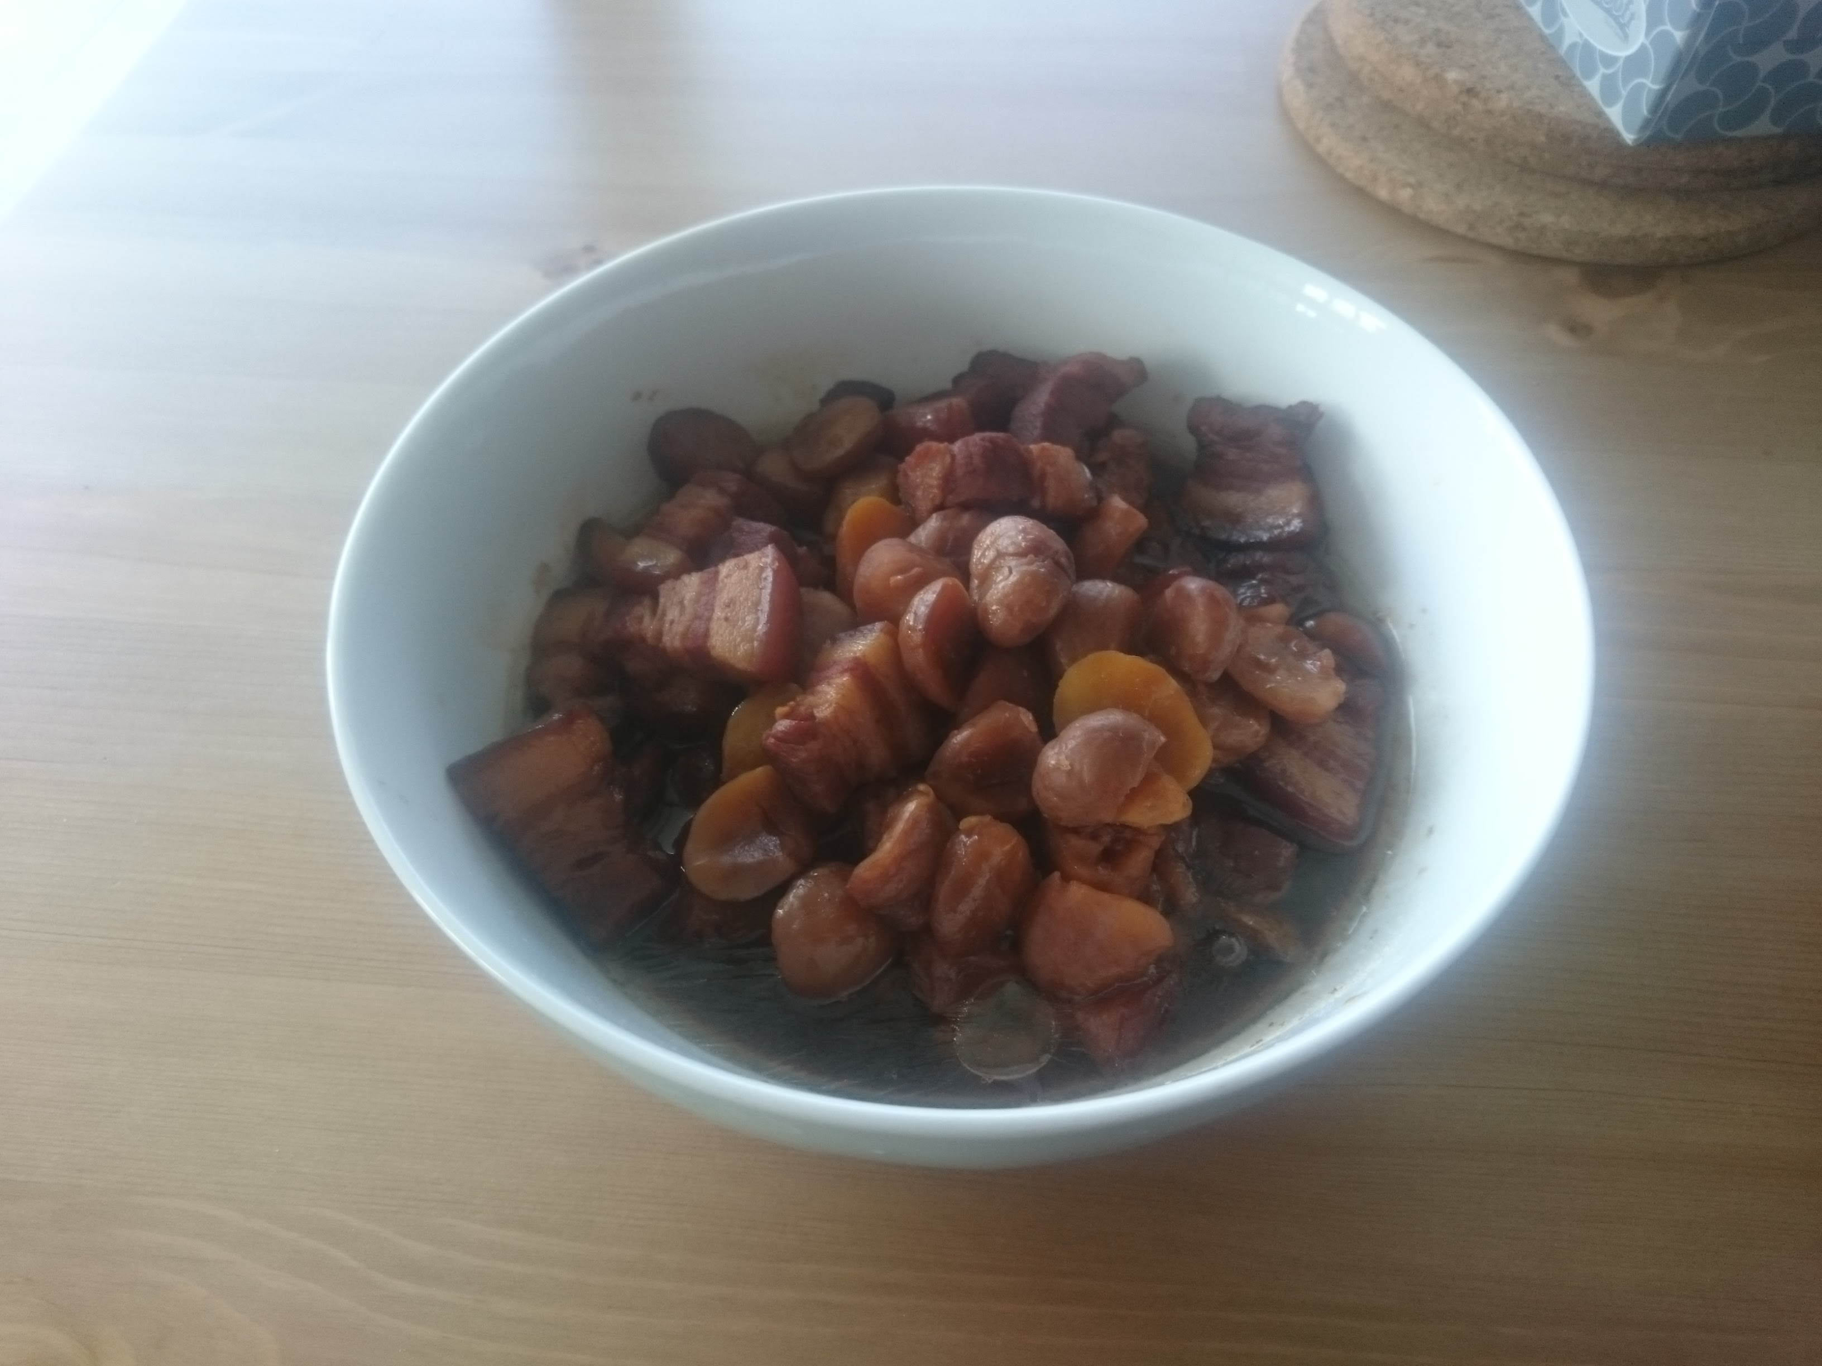

Dinner

and rice

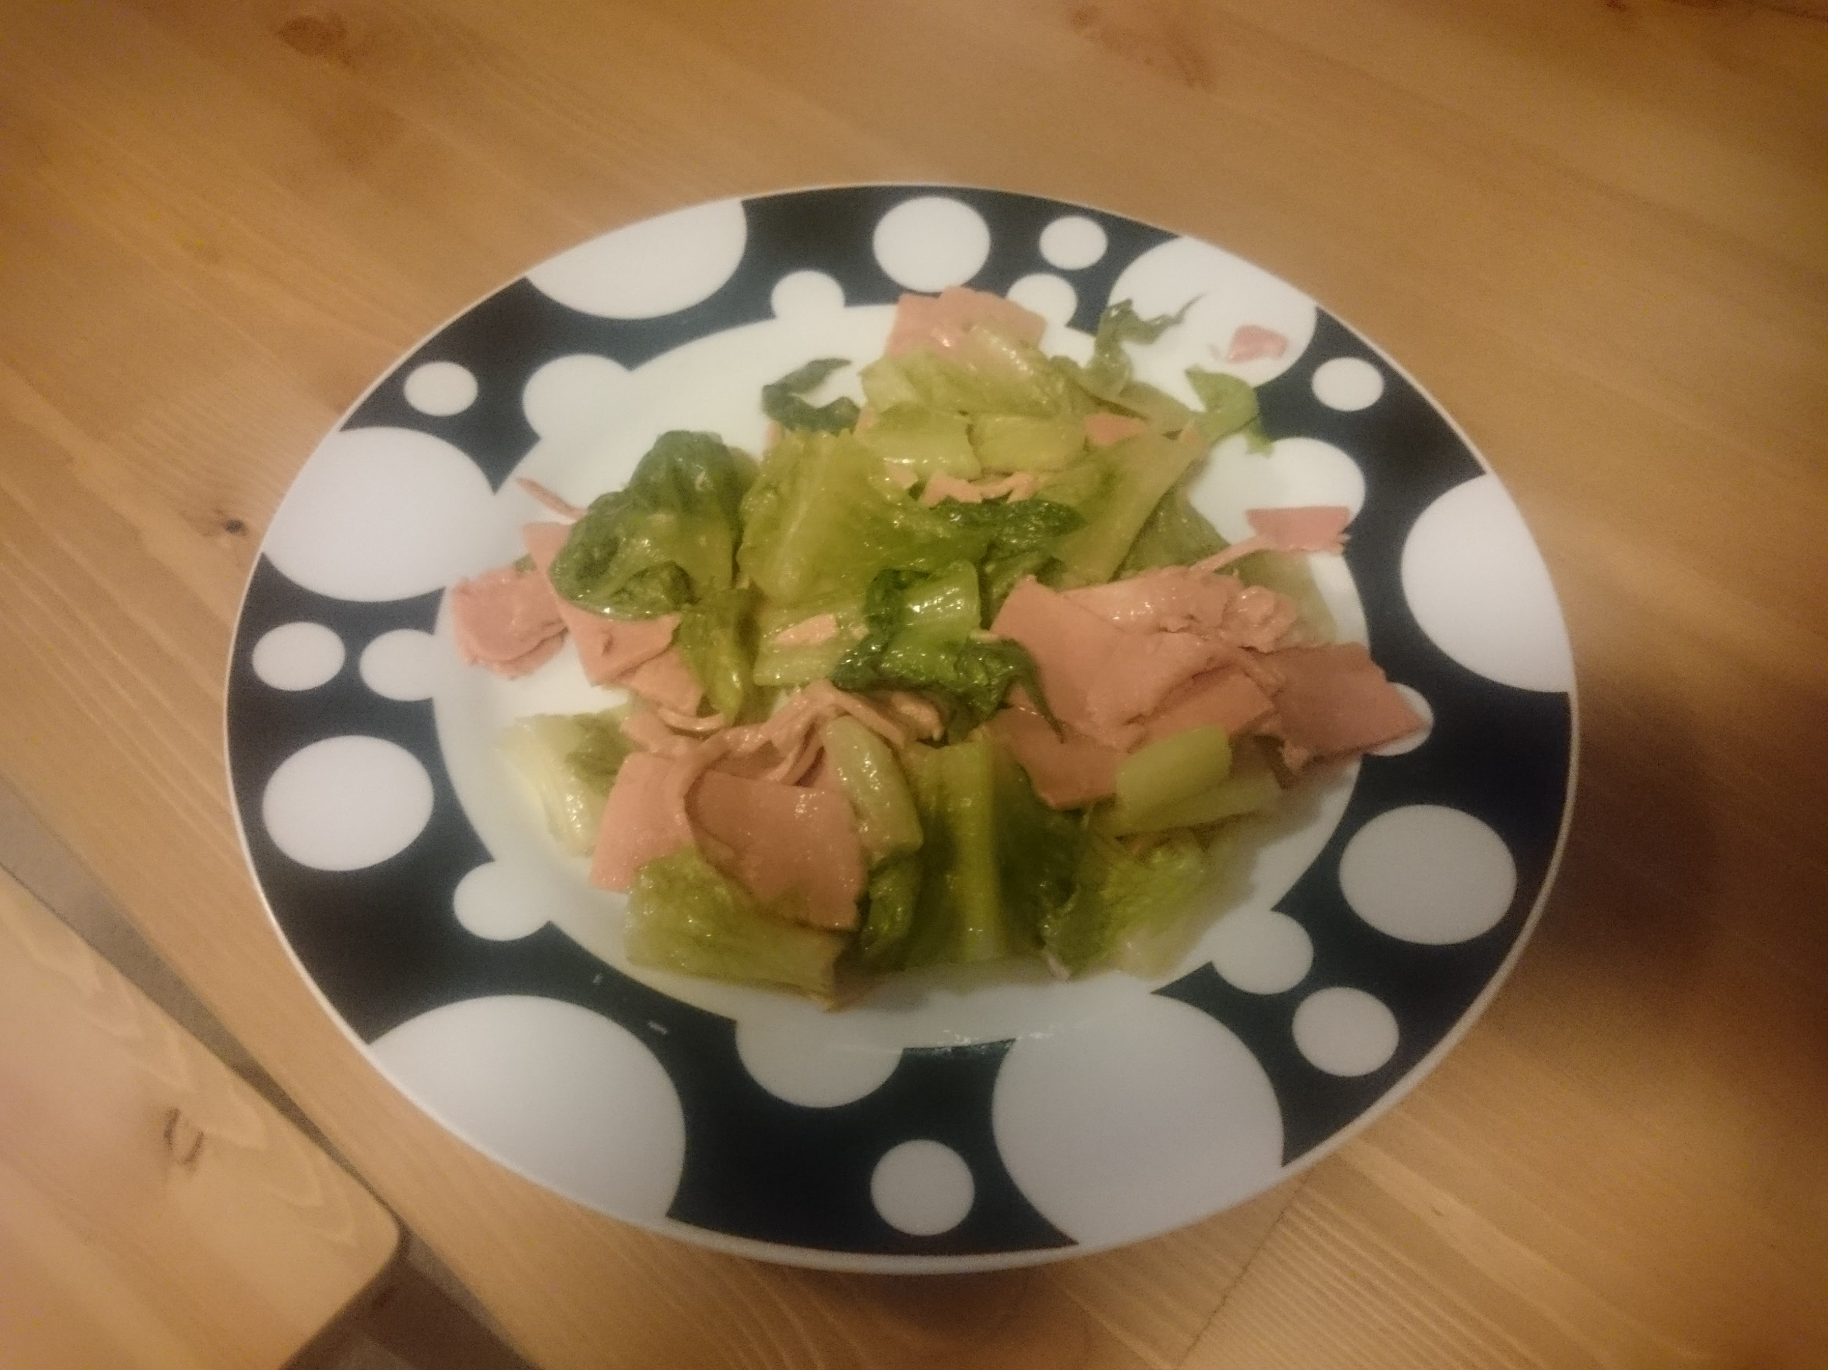

Friday

Breakfast

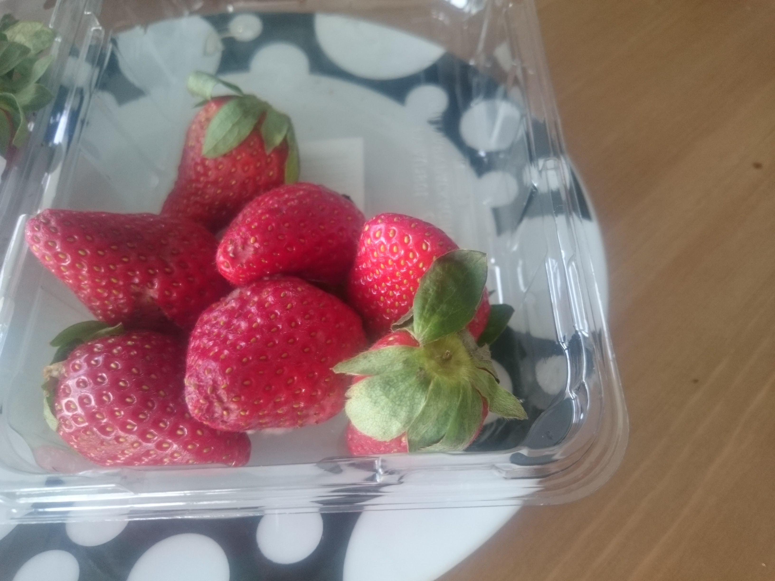

Lunch Dinner and Saturday….forgot…

Reflective Summary

Logging daily food by photograph is not finished well by me. It is always happened that I could only realize to take photos on my meal just when I finished eating. In addition, my timetable has many variations in the weekdays so that setting an alarm is not a good reminding way. It is difficult to accurately express the actual intake by the pictures taken as it is not all eaten.